**DAILY ONLINE ACTIVITIES SUMMARY**

|  |  |  |  |  |  |  |  |  |
| --- | --- | --- | --- | --- | --- | --- | --- | --- |
| **Date:** | **27-06-2020** | | | | | **Name:** | **Anix Jugal D’Cunha** | |
| **Sem & Sec** | **8 sem , A sec** | | | | | **USN:** | **4AL16CS013** | |
| **Online Test Summary** | | | | | | | | |
| **Subject** | | **Test was not conducted Today** | | | | | | |
| **Max. Marks** | | **--** | | **Score** | | | **--** | |
| **Certification Course Summary** | | | | | | | | |
| **Course** | **Learn to code with html from beginner to expert** | | | | | | | |
| **Certificate Provider** | | | **Udemy** | | **Duration** | | | 1 hour |
| **Coding Challenges** | | | | | | | | |
| **Problem Statement:** Reconstruct the array by replacing arr[i] with (arr[i-1]+1) % M | | | | | | | | |
| **Status: Competed** | | | | | | | | |
| **Uploaded the report in Github** | | | | | **yes** | | | |
| **If yes Repository name** | | | | | **alvas-education-foundation/dcunhaanixjugal** | | | |
| **Uploaded the report in slack** | | | | | **yes** | | | |

Online Test Details: (Attach the snapshot and briefly write the report for the same)

Test was not conducted Today

Certification Course Details: (Attach the snapshot and briefly write the report for the same)

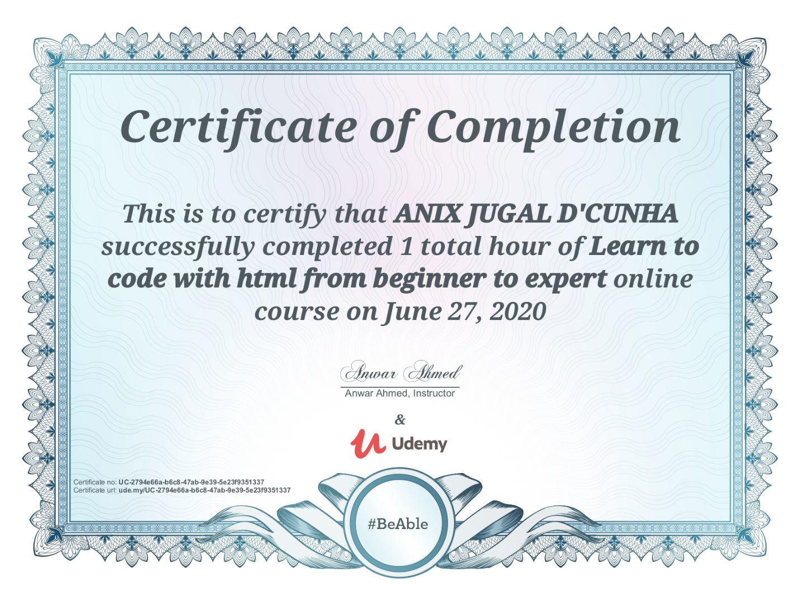

Coding Challenges Details: (Attach the snapshot and briefly write the report for the same)

## Program-> Reconstruct the array by replacing arr[i] with (arr[i-1]+1) % M

## def construct(n, m, a):

## ind = 0

## 

## # Finding the index which is not -1

## for i in range(n):

## if (a[i]!=-1):

## ind = i

## break

## 

## # Calculating the values of the indexes ind-1 to 0

## for i in range(ind-1, -1, -1):

## if (a[i]==-1):

## a[i]=(a[i + 1]-1 + m)% m

## 

## # Calculating the values of the indexes ind + 1 to n

## for i in range(ind + 1, n):

## if(a[i]==-1):

## a[i]=(a[i-1]+1)% m

## print(*a)

## 

## # Driver code

## n, m = 6, 7

## a =[5, -1, -1, 1, 2, 3]

## construct(n, m, a)